Parish Profile - St. Andrews Church, Corton Denham
St. Andrew’s church is part of the Cam Vale Benefice, a group of six churches: West Camel, Queen Camel, Sparkford, Weston Bamfylde and Sutton Montis, which lies in the Deanery of Bruton and Cary under the umbrella of the Diocese of Bath and Wells and our Mother Church, the Wells Cathedral.
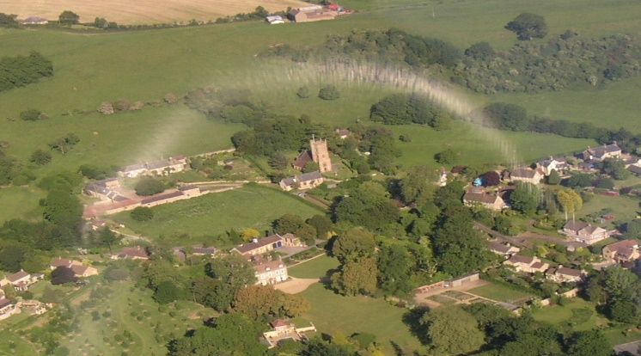
The population of Corton Denham consists of a few farmers, young families and, predominantly active, retired people. There are also many 'visiting grandchildren.'
The Church is regularly attended by a small congregation of around 15, rising to over 70 at special events. These include a Sunrise Service at the Beacon on Easter morning; very popular Remembrance, Harvest and Christmas-time Services and the occasional Pet Service.
The church, originally built in the 12th century, has been re-built in 1870 of local stone in a traditional style.
The community of Corton Denham pulls together with individuals responsible for various aspects of the village, including the churchyard, closed for burials 100 years ago. Its maintenance now rests with the Parish Council. The village has an inter- and non-denominational cemetery with a large capacity, which doubles as an attractive wildlife area maintained jointly, by the Parochial Church Council and Parish Council
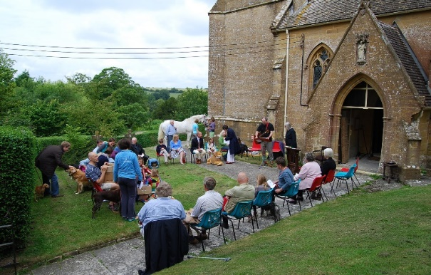
Services. Currently we are going through an Interregnum.
A single monthly service in St Andrews Church is rounded up with additional celebrations of the many traditional and joyful events of the year, Life Services and occasional impromptu, “homemade” services. .
Our congregation is also happy to join services in other churches within the Benefice.
Church Organisation.
Currently, the Electoral Roll stands at 52 souls.
The PCC consists of 6 members and 4 “Friends” taking part in decisions and contributing with some wonderful ideas and support. The aim of the PCC is to involve villagers in church events and to coordinate these with village events wherever possible. There is a deliberate policy to delegate church related tasks to a wide range of people. Around 46 regular volunteers cover all aspects of Church life such as flower arranging, cleaning and bell ringing. The church is open daily and is popular with visitors and those seeking reflection. 'The Corton Denham News' published by the church and distributed to every home covers all aspects of village life, together with TWA, a weekly electronic notice sheet which includes all events and news items in and around the village.
Finance. St Andrew’s church is financially sound, with an income normally sufficient to maintain the building and the cemetery.
Charitable Support. The church embraces various charities, the preferred one is 'The Lord's Larder' providing support to the needy around Yeovil.
Music is important to most in the parish.
Parish Agenda. The emphasis is to be part of the community and to build up the congregation, while staying in close contact with other churches within the Benefice. There needs to be continuous awareness of rural life, of problems including those of an ageing population in need of care, and both physical and spiritual loneliness. The authority of Scripture exercised with prayerful understanding is central.
St Andrew’s Church seeks to retain Christian faith, culture and traditions, while looking over a widely extended and broad-minded spiritual scene. It is committed to providing a centre for worship and for spiritual support to all without exclusion.
